Element 1 – System Design (UML Diagrams)

Use Case Diagram

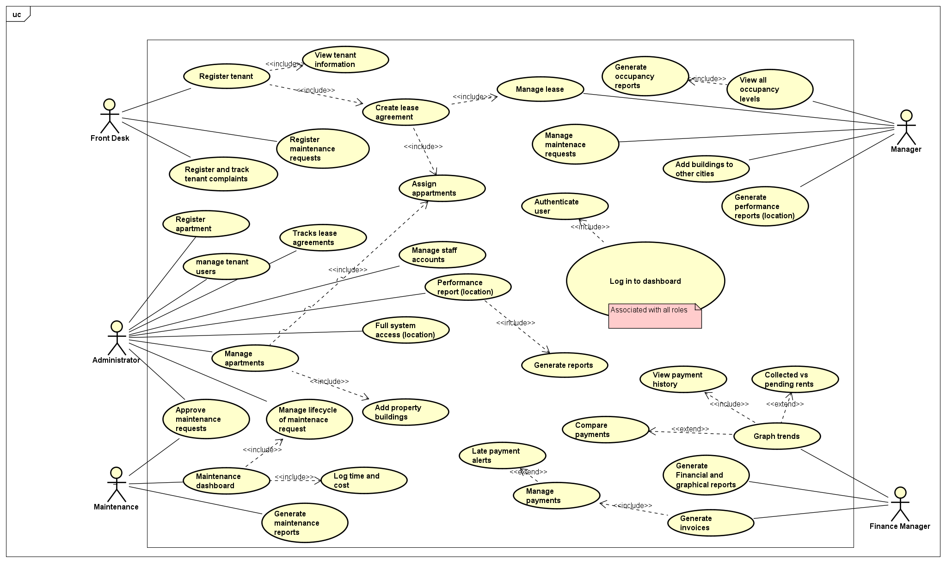

Class Diagram

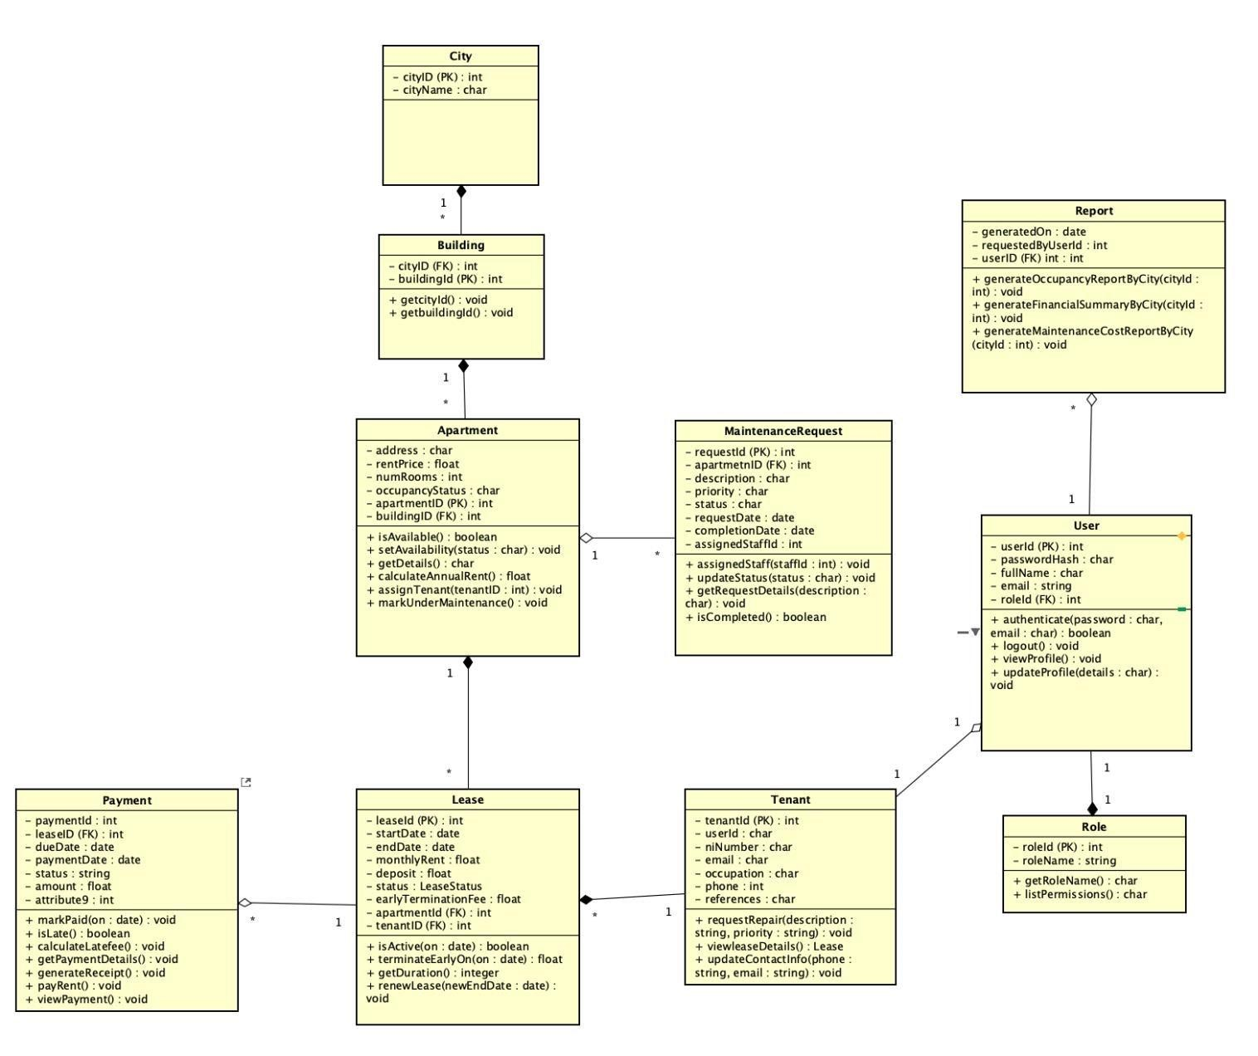

Sequence Diagram – Authentication

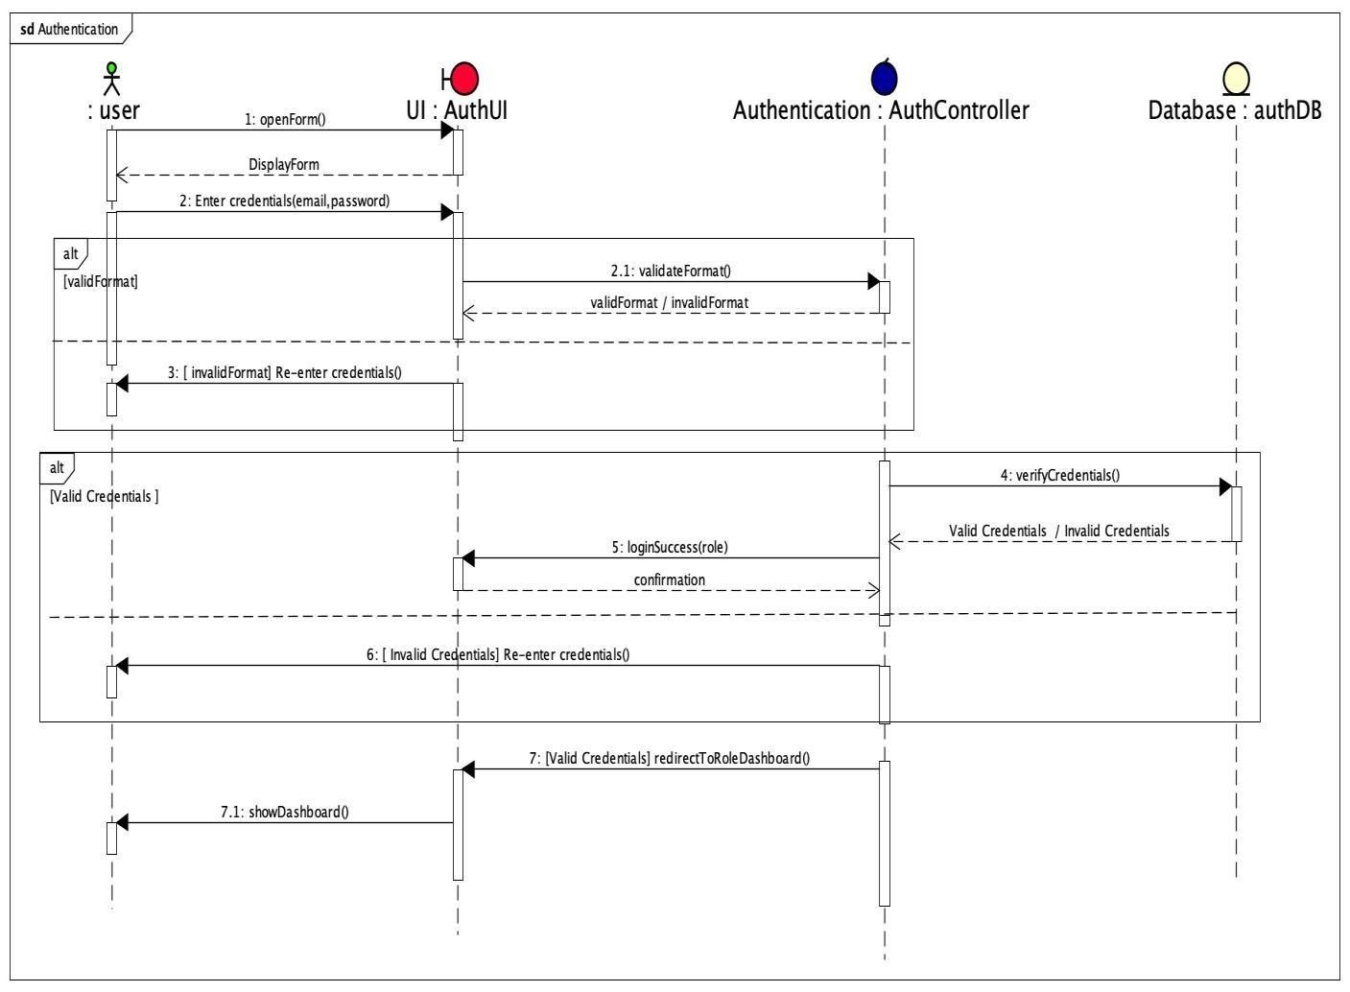

Sequence Diagram – Register and track Maintenance Request
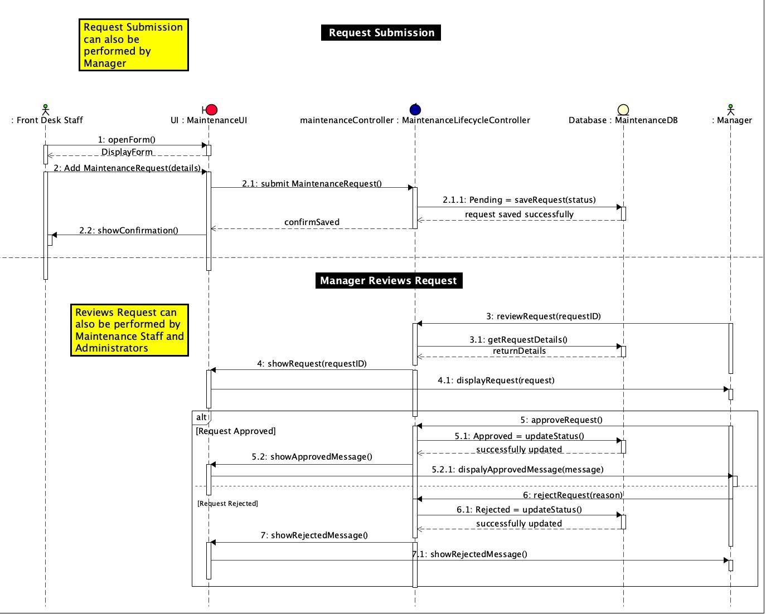

Sequence Diagram – Register Apartment

